

ACTIVITY ONE - AN INTRODUCTION

# STUDENT WORKSHEET

School Name Student Name

Year Level

## Quiz questions

### Listen to Farmer Bill’s Video One

1. How long has Farmer Bill been farming for?
2. How many employees does Farmer Bill have on his farm?
3. How many cows does Farmer Bill milk?
4. What are the three main food sources of Farmer Bill’s milkers?
5. If Bill has 700 cows on 283 hectares, then how many cows does Bill have per hectare?
6. If Bill has 48 newborn calves how much colostrum milk will he need in the first 12 hours?

### Listen to the MaxCare Video

**1.** What tools would a person need to mix MaxCare milk powder?

**4.** What are the names of the two Cows Create Careers calves?

1. Which of the range of MaxCare milk powders are they mixing in the video?
2. How much colostrum milk do calves receive in the first 12 hours after being born?
3. How long are the calves kept in the shed / pen environment?
4. What are the two main food types that the calves receive in the pen?
5. How many kilograms of MaxCare milk powder would a person need to make 8 litres of milk for the calves?
6. The calves at 3 weeks old will need 3-3.5 litres of MaxCare milk powder twice a day. If you are feeding 8 calves for 30 days how many litres of MaxCare milk powder will the calves consume?

**8.** What is the calves bedding made from?

1. Identify the type of information that MaxCare has on the back of their milk powder bag?

**9.** At the age of 15 months the calves are joined,

what age do they come into the herd as milkers?

1. If a supplier orders 5 bags of MaxCare milk powder, each bag is 20kg. How many litres of milk can the farmer make?



**12**

### Read about the Australian Dairy Industry

* 1. How much of Australian milk production is exported overseas?

### List who made the products and their brand?

What is the product type?

* 1. What is the average dairy herd size in Australia?

Who manufactured the product?

* 1. How many dairy cows do we have in Australia?

What is the brand?

* 1. We consume kg of cheese and

litres of milk per capita

* 1. Dairy is the largest rural industry in Australia

**Write down 100 words on what you have learnt about rearing healthy calves, use your own language?** [Primary Students: 50 words or 8 dot points]

**Research and list 5 benefits of having dairy in your diet to help with your health & wellbeing**

**List the dairy products that you can find in your fridge and/or pantry?**

**Get ready to plot/graph the weight gain of Bright & Future, our Holstein calves.**

For older students you may wish to research Holstein calves weight gains and plot comparisons.

**Week 1** Bright 50kg

Future 51kg



**13**

ACTIVITY TWO - TECHNOLOGY

# STUDENT WORKSHEET

School Name Student Name

### Find the answers (Farmer Bill)

1. What is the identification tag called that Farmer Bill uses?

Year Level

## Word find questions

### Listen to Farmer Bill’s Video 2 and the Daviesway Video

**Find the answers (Daviesway)**

* 1. How many doors does the Boumatic MRS1 Milking Robot have?
  2. On the platform what can the computer read?
  3. Once the computer identifies the cows what can it then adjust?
  4. What is herd test used for on Bill’s farm?

**2.** What is setup to allow the robot to select the cows?

**5.** What type of shed does Farmer Bill own?

1. How does the Robot identify each cow?

### Note: Please find these answers in the word find on the following page.



**17**

1. What drops into a tray if the Robot determines the cows should be milked?
2. What does the milking arm have that helps guide it to the cows’ udder?
3. What happens to the teat cups when they are returned to their protective holder?
4. After the cows are milked, what happens to her teats?
5. How can all the data for the cow be viewed?

**FO — —**

|  |  |  |  |  |  |  |  |  |  |  |  |  |  |  |  |  |  |  |  |
| --- | --- | --- | --- | --- | --- | --- | --- | --- | --- | --- | --- | --- | --- | --- | --- | --- | --- | --- | --- |
| **D** | **U** | **V** | **M** | **K** | **K** | **N** | **L** | **J** | **W** | **B** | **E** | **Y** | **E** | **S** | **L** | **D** | **P** | **I** | **S** |
| **R** | **T** | **M** | **G** | **W** | **I** | **S** | **F** | **Q** | **I** | **U** | **L** | **V** | **P** | **O** | **P** | **U** | **R** | **S** | **W** |
| **X** | **J** | **Y** | **C** | **D** | **L** | **B** | **E** | **C** | **W** | **I** | **O** | **S** | **I** | **P** | **M** | **D** | **U** | **G** | **M** |
| **B** | **B** | **Q** | **K** | **V** | **C** | **I** | **E** | **K** | **F** | **C** | **E** | **H** | **O** | **H** | **I** | **X** | **O** | **B** | **B** |
| **J** | **I** | **U** | **K** | **S** | **A** | **B** | **D** | **E** | **R** | **L** | **L** | **V** | **J** | **K** | **L** | **Y** | **F** | **P** | **U** |
| **N** | **E** | **E** | **S** | **T** | **W** | **Q** | **R** | **U** | **E** | **Q** | **V** | **P** | **A** | **J** | **K** | **R** | **R** | **Z** | **D** |
| **U** | **E** | **G** | **G** | **B** | **G** | **R** | **A** | **C** | **C** | **X** | **U** | **D** | **S** | **D** | **P** | **B** | **B** | **V** | **P** |
| **O** | **D** | **E** | **Y** | **U** | **B** | **M** | **T** | **I** | **Q** | **V** | **I** | **V** | **Y** | **J** | **R** | **X** | **R** | **L** | **W** |
| **R** | **H** | **X** | **R** | **J** | **I** | **I** | **I** | **X** | **A** | **S** | **X** | **J** | **Z** | **B** | **O** | **E** | **E** | **C** | **L** |
| **Z** | **N** | **V** | **F** | **C** | **O** | **M** | **O** | **C** | **I** | **A** | **S** | **I** | **R** | **H** | **D** | **T** | **D** | **F** | **N** |
| **U** | **X** | **C** | **S** | **N** | **S** | **O** | **N** | **N** | **A** | **B** | **A** | **D** | **Q** | **X** | **U** | **P** | **N** | **C** | **J** |
| **Q** | **C** | **D** | **Z** | **I** | **P** | **H** | **F** | **P** | **D** | **M** | **T** | **X** | **R** | **I** | **C** | **D** | **O** | **Z** | **N** |
| **R** | **Z** | **O** | **G** | **K** | **L** | **E** | **C** | **Z** | **A** | **K** | **E** | **C** | **G** | **N** | **T** | **R** | **P** | **G** | **G** |
| **H** | **N** | **C** | **G** | **E** | **C** | **N** | **N** | **U** | **O** | **J** | **W** | **R** | **S** | **A** | **I** | **W** | **S** | **A** | **A** |
| **E** | **R** | **H** | **Q** | **T** | **S** | **U** | **L** | **D** | **O** | **R** | **X** | **A** | **A** | **T** | **O** | **Y** | **N** | **O** | **G** |
| **I** | **F** | **U** | **E** | **N** | **L** | **J** | **X** | **C** | **H** | **T** | **H** | **Y** | **S** | **U** | **N** | **F** | **A** | **Q** | **Y** |
| **X** | **V** | **D** | **H** | **L** | **D** | **T** | **B** | **Y** | **R** | **A** | **T** | **O** | **R** | **H** | **G** | **E** | **R** | **O** | **F** |
| **C** | **H** | **E** | **A** | **T** | **D** | **E** | **T** | **E** | **C** | **T** | **I** | **O** | **N** | **D** | **E** | **E** | **T** | **V** | **G** |
| **N G** | **V D** | **H H** | **Z C** | **M Z** | **N N** | **L I** | **L I** | **E E** | **W X** | **T V** | **U K** | **G F** | **C C** | **O I** | **Q Q** | **D I** | **N P** | **F G** | **I V** |

**SE — — — — — — — ZO — —**

**T R — — — — — — — — — FE — —**

**CA — — — —**

**WA — — — —**

**D I — — — — — — — — —**

**TO — — — S C — — — — NL — —**

**MI — — PR — — — — — — — — FE — — R A — — — —**

**HE — — DE — — — — — — — RO — — — —**

### Read about the different types of milking sheds in Australia.

Write 100 words about which one you would choose and why you would make this choice? You may wish to research the internet to reinforce the reason for your decision ie. price, efficiency, labour, lifestyle.

Primary Students: 50 words or 8 dot points]

### Now it is time to critique, analyse and investigate your design:

1. Tell us the benefit of your design and why it has great functionality and purpose?
2. Suggest some modifications to the design that may improve its functionality and purpose?

### Attach a picture of your innovative milking shed design then email the photo (JPG) to your teacher. Involve your family in helping to build your design.

**Note:** For junior students you may wish to use one of the current milk shed designs as a starting

point. For senior students you may wish to design a completely new design

### Following are the latest weights of Bright and Future our Holstein calves, please add these to your plot/graph

**Week 2** Bright 54.5kg

Future 55kg



**18**

ACTIVITY THREE - ENVIRONMENT/NATURAL RESOURCES

# STUDENT WORKSHEET

School Name Student Name



**22**

Year Level

## Crossword clues

### Listen to Farmer Bill’s Video 3 and the Jamie Durie Groundswell Platform Video (hyperlink to videos)

**Clues from Jamie’s video**

* Wilko & Sandra Droppert are dairyfarmers who have the aim to become carbon neutral by largely storing more carbon in the [4 Down]
* The Droppert Family plan to use , wind and batteries to reduce their carbon footprint [7 Across]
* Brad Ridoutt, CSIRO stated that if Australians shifted to eat more like the way we are recommended to by the dietary guidelines then overall our gas emissions would go down by 12 percent [5 Across]
* Ad van Dijk from Lion Dairy & Drinks stated that the company’s aim is to have a zero footprint and landfill target, they are producing a made bottle to reduce their footprint [9 Down]

### Clues from Bill’s video

* In 1991-92 Farmer Bill helped start up the Mount Lyall group and has been an active conservationist member since [2 Down]
* Farmer Bill the waterways and remnant vegetation to improve water quality [8 Across]
* Melbourne Water are now taking on the responsibility for improving the bigger water front edges as it helps improve from entering the main river ways [3 Down]
* The addition of along the waterways has made the farm look a whole lot more aesthetically beautiful [1 Down]
* Farmer Bill is utilising the from the dairy to grow crops and improve the soil to grow grass in the summertime. [6 Down]

**Note: Complete the crossword over the page using your answers**

## Crossword

### Write 100 words on what the dairy industry is doing to improve land management, increase water use efficiency, reduce greenhouse gas emissions, intensity and reduce waste. Use the links in your information sheet.

You may wish to research the internet to learn some more about what dairy is doing to achieve this.

Primary Students: 50 words or 8 dot points]

### You will have submitted a 60 second video on how to manage waste in your household.

Can you please tell us how you currently manage waste and identify two ways that you could improve managing your waste and/or environmental footprint.

How do you do it now?





**1**

**2**

**3**

**4**

**5**

**6**

**7**

**8**

**9**

### How can you do it better?

**Following are the latest weights of Bright and Future our Holstein calves, please add these to your plot/graph**

**Week 3** Bright 62.7kg

Future 63.1kg

**23**





*Reference: Dairy Australia*

**27**

ACTIVITY FOUR - KEEPING COMMUNITIES FARM SAFE

# STUDENT WORKSHEET

School Name Student Name Year Level

## Spot the difference

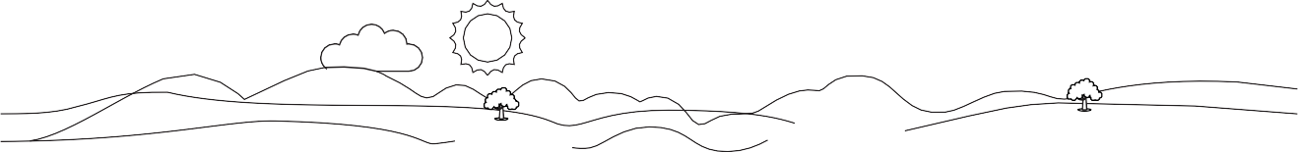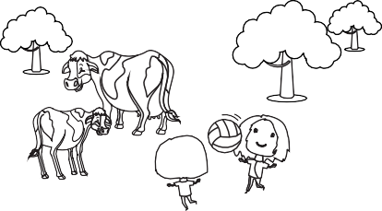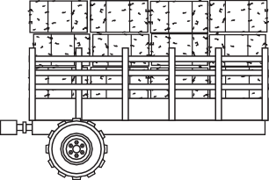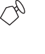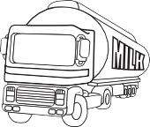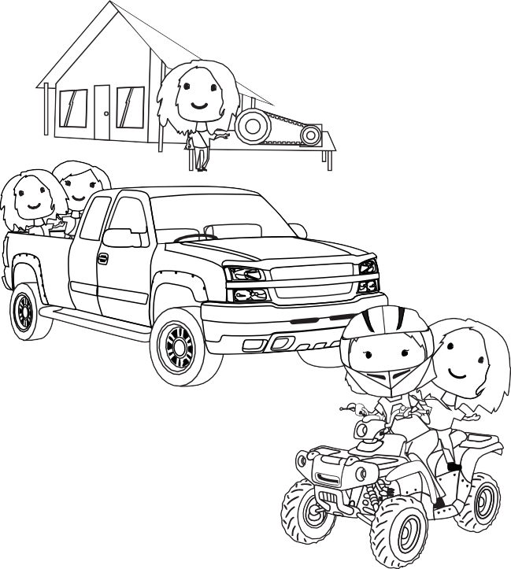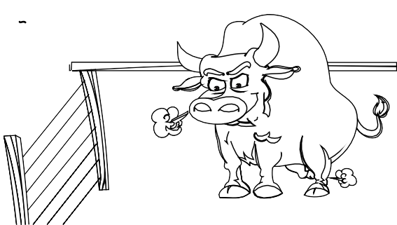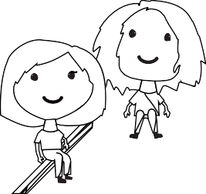

**8**

**4**

**3**

**2**

**6**

**5**

**7**

**1**

❶ .

❺

❷

❻

❸

❼

❹

❽





**28**

## A - Z farm safety checklist

Use each letter of the alphabet below to identify a potential hazard / risk that may be found on a dairy farm and then provide an explanation as to how to minimise this risk. Use your own words. A Farm lego guide example has been provided with ideas. [Teachers: students can either complete below or develop a entire guide/booklet, the choice is yours]

|  |  |  |
| --- | --- | --- |
| A is for |  | Minimise the risk by: |
| B is for |  | Minimise the risk by: |
| C is for |  | Minimise the risk by: |
| D is for |  | Minimise the risk by: |
| E is for |  | Minimise the risk by: |
| F is for |  | Minimise the risk by: |
| G is for |  | Minimise the risk by: |
| H is for |  | Minimise the risk by: |
| I is for |  | Minimise the risk by: |
| J is for |  | Minimise the risk by: |
| K is for |  | Minimise the risk by: |
| L is for |  | Minimise the risk by: |
| M is for |  | Minimise the risk by: |
| N is for |  | Minimise the risk by: |
| O is for |  | Minimise the risk by: |
| P is for |  | Minimise the risk by: |
| Q is for |  | Minimise the risk by: |
| R is for |  | Minimise the risk by: |
| S is for |  | Minimise the risk by: |
| T is for |  | Minimise the risk by: |
| U is for |  | Minimise the risk by: |
| V is for |  | Minimise the risk by: |
| W is for |  | Minimise the risk by: |
| X is for |  | Minimise the risk by: |
| Y is for |  | Minimise the risk by: |
| Z is for |  | Minimise the risk by: |

**Home safety**

Please identify the most hazardous room in your home below and then list two different examples of how you could minimise or prevent injury.

### Describe the hazard

**List two different examples of how to minimise the hazard**

1.

### Attach a picture of your hazard before and after then email these photos (JPG’s) to your teacher. Involve your family with your thinking.

**Following are the latest weights of Bright and Future our Holstein calves, please add these to your plot/graph**

**Week 4** Bright 65kg

Future 65.5kg



**29**

2.

ACTIVITY FIVE - MARKETING AND DAIRY CAREERS

# STUDENT WORKSHEET

School Name Student Name Year Level

### Research and identify three career pathways in the dairy industry using the information sheet.

Write a paragraph about those three career pathways and what the career involves:



**Here are the last weights of Bright & Future our Holstein calves, please submit your final plot/ graph to your teacher for assessment.**

**Week 5** Bright 69kg

Future 69.5kg

**33**

### Select one company from the information sheet and design a new sales pitch and logo below.

PITCH:

LOGO: [Students may wish to attach the logo separately]